# CS 305 Module Five Coding Assignment Checksum Verification Template

## Instructions

Using the instructions from theModule Five Coding Assignment Checksum Verification Guidelines and Rubric, replace the bracketed text with the relevant information in your own words.

## Algorithm Cipher

I recommend using the SHA-256 (Secure Hash Algorithm 256-bit). This algorithm is known for its strong collision resistance, which means while it is possible, it is not likely that two different inputs will produce identical hash values. (*Java Security Standard Algorithm Names*, 2025)

## Justification

SHA-256 is designed by the National Security Agency (NSA). It produces a 256-bit hash value, typically rendered as a hexadecimal number. The main reasons for choosing SHA-256 are that it is designed to be collision resistant and very difficult to find two different inputs producing the same hash value. Itis widely used and has been thoroughly tested by the cryptographic community, making it highly trusted. Finally, while there are other algorithms that are faster, SHA-256 has a good balance between performance and security.(*Java Security Standard Algorithm Names*, 2025)

## Generate Checksum

You’ll submit your refactored code to your instructor. Your instructor will review it and this document.

## Verification

Insert a screenshot below of the web browser with your unique information.

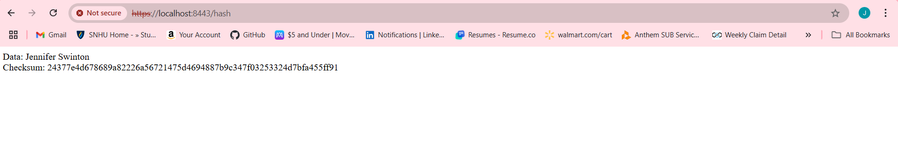

References:

*Java Security Standard Algorithm Names*. (2025, January 10). https://docs.oracle.com/en/java/javase/11/docs/specs/security/standard-names.html?form=MG0AV3